

**Department of Computer Science & Engineering**

**B.Sc. in Computer Science &Engineering**

**Course Tittle:** Object Oriented Programming

**Course Code:** CSE 215

**Submitted By**

**Name:** Hasmun Nahar Hasi

**ID:**0272130005101136

**Batch**: 58th

**Section:** B

**Submitted To**

**Debobrata Chakraborty**

**Lecturer**

**Department of CSE**

**City University**

# Submission Date :12/09/2025

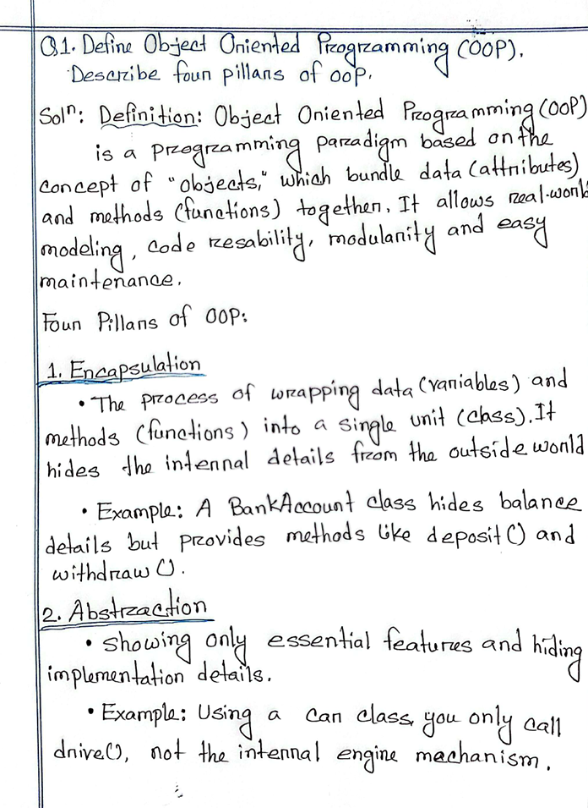

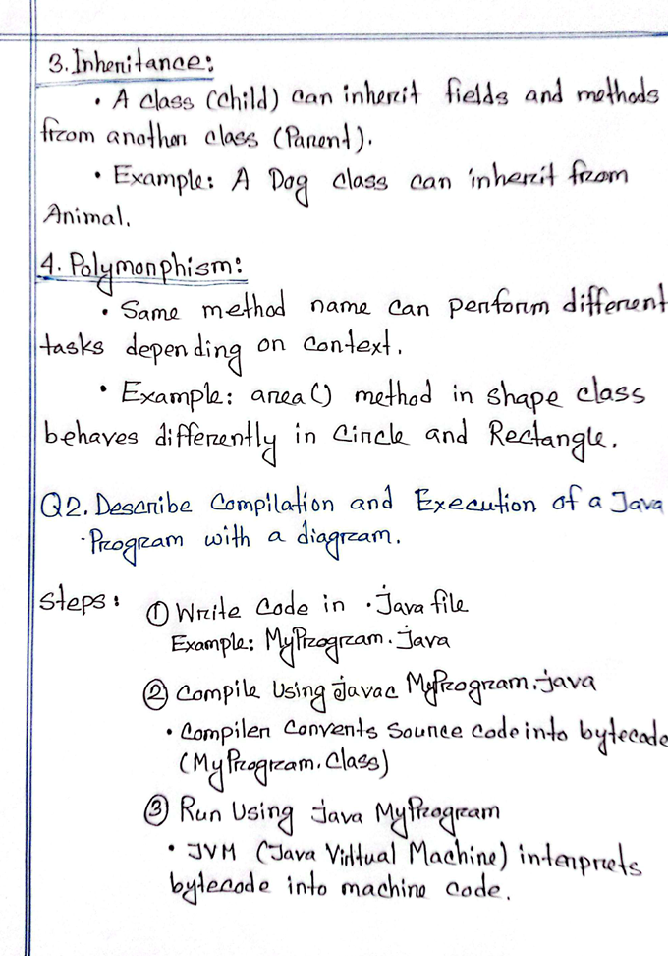

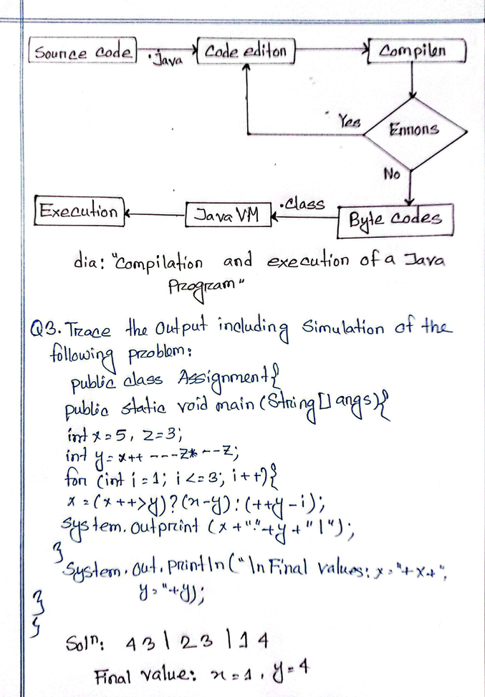

**1.Write a java program to print all natural numbers in reverse (from n to 1) using while loop.**

package reversenaturalnumbers;

import java.util.Scanner;

public class ReverseNaturalNumbers {

public static void main(String[] args) {

Scanner sc = new Scanner(System.in);

System.out.print("Enter number (n):");

int n = sc.nextInt();

while (n >= 1) {

System.out.println(n);

n--;

}

sc.close();

}

}

**Output:**

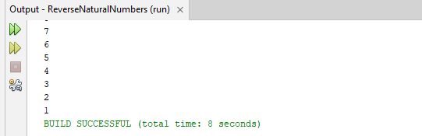

**2. Write a java program to print all alphabets from a to z- using while loop.**

package alphabate;

public class Alphabate {

public static void main(String[] args) {

char ch = 'a';

while (ch <= 'z') {

System.out.print(ch + " ");

ch++;

}

}

}

**Output:**

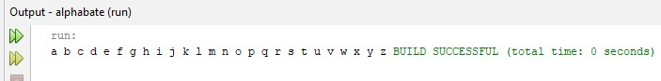

**3. Write a java program to print sum of all even number between 1 to n.**

package evennumber;

import java.util.Scanner; public class EvenNumber {

public static void main(String[] args) {

Scanner sc = new Scanner(System.in);

System.out.print("Enter a number (n): ");

int n = sc.nextInt();

int sum=0;

int i;

for(i=2;i<=n;i=i+2){

sum=sum+i;

}

System.out.println("Sum of even number =" +sum);

}

}

**Output:**

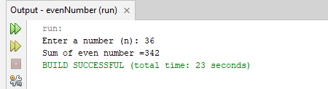

**4. Write a java program to print sum of all odd number between 1 to n.**

package oddnumber;

import java.util.Scanner;

public class OddNumber {

public static void main(String[] args) {

Scanner sc = new Scanner(System.in);

System.out.print("Enter a number (n): ");

int n = sc.nextInt();

int sum=0;

int i;

for(i=1;i<=n;i=i+2){

sum=sum+i;

}

System.out.println("Sum of Odd number =" +sum);

}

}

**Output:**

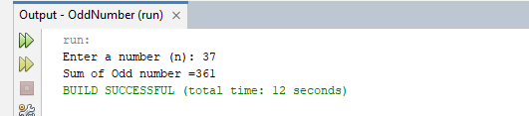

**5. Write a java program to print prime number between 1 to n.**

package primenumber;

public class PrimeNumber { public static void main(String[] args) {

int n = 19;

boolean isPrime = true;

if (n <= 1) {

isPrime = false;

} else {

for (int i = 2; i <= n / 2; i++)

{

if (n % i == 0) {

isPrime = false;

break;

}

}

}

if (isPrime)

System.out.println(n + " is a Prime number.");

else

System.out.println(n + " is NOT a Prime number.");

}

}

**Output:**

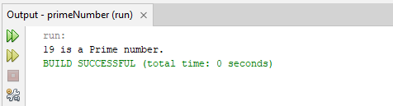

**6. Write a java program to print table of any number.**

package tableofnumber;

import java.util.Scanner;

public class TableOfNumber {

public static void main(String[] args) {

Scanner sc = new Scanner(System.in);

System.out.print("Enter a number (n): ");

int n = sc.nextInt();

for (int i = 1; i <= 10; i++) {

System.out.println(n + " x " + i + " = " + (n * i));

}

sc.close();

}

}

**Output:**

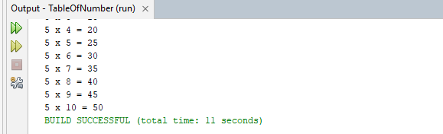

**7. Write a java program to enter any number and calculate sum of all natural numbers between 1 to n**.

package naturalnumber;

import java.util.Scanner;

public class NaturalNumber {

public static void main(String[] args) {

Scanner sc = new Scanner(System.in);

System.out.print("Enter number: ");

int n = sc.nextInt();

int count = 0;

int temp = n;

while (temp != 0) {

temp = temp / 10;

count++;

}

System.out.println("Total digit: " + count);

}

}

**Output:**

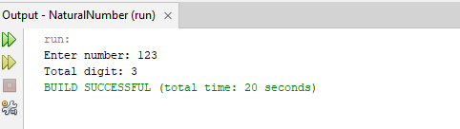

**8. Write a java program to find first and last digit of any number**. package lastdigit;

import java.util.Scanner; public class LastDigit {

public static void main(String[] args) {

Scanner sc = new Scanner(System.in); System.out.print("Enter number: "); int n = sc.nextInt();

int last = n % 10;

int first = n;

while(first >= 10){

first /= 10;

}

System.out.println("First Digit = " + first);

System.out.println("Last Digit = " + last);

}

}

**Output:**

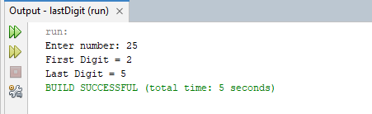

**9. Write a java program to count number of digits of any number.**

package countnumber;

import java.util.Scanner;

public class CountNumber {

public static void main(String[] args) {

Scanner sc = new Scanner(System.in); System.out.print("Enter number: "); int n = sc.nextInt();

int count = 0;

while(n > 0){

count++;

n /= 10;

}

System.out.println("Total Digits = " + count);

}

}

**Output:**

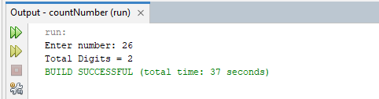

**10. Write a java program to calculate sum of digits of any number.**

package sumofdigit;

import java.util.Scanner; public class SumOfDigit { public static void main(String[] args) {

Scanner sc = new Scanner(System.in); System.out.print("Enter number: "); int n = sc.nextInt();

int sum = 0;

while(n > 0){

sum += n % 10;

n /= 10;

}

System.out.println("Sum of digits = " + sum);

}

}

**Output:**

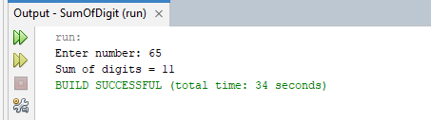

1. **Write a java program to Calculate product of digits of any number.**

package productofdigit;

import java.util.Scanner;

public class ProductOfDigit {

public static void main(String[] args) {

Scanner sc = new Scanner(System.in); System.out.print("Enter number: "); int n = sc.nextInt();

int product = 1;

while(n > 0){

product *= (n % 10);

n /= 10;

}

System.out.println("Product of digits = " + product);

}

}

**Output:**

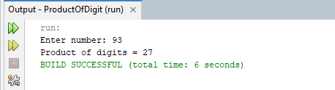

1. **Write a java program to Swap first and last digits of any number.**

package swap**;**

package swap;

import java.util.Scanner;

public class Swap {

public static void main(String[] args) {

Scanner sc = new Scanner(System.in); System.out.print("Enter number: "); int n = sc.nextInt();

String s = Integer.toString(n);

char[] arr = s.toCharArray();

char temp = arr[0];

arr[0] = arr[arr.length-1]; arr[arr.length-1] = temp;

System.out.println("After Swapping: " + new String(arr));

}

}

**Output:**

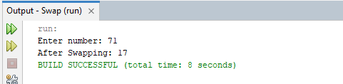

**13. Write a java program to Find sum of first and last digit of any number.**

package sumfirst.lastdigit;

import java.util.Scanner; public class SumOfFirstLastDigit {

public static void main(String[] args) {

Scanner sc = new Scanner(System.in); System.out.print("Enter number: "); int n = sc.nextInt();

int last =n%10;

int first =n;

while(first >= 10){

first = first/10;

}

System.out.println("Sum of digits = " + (first+last));

}

}

**Output:**

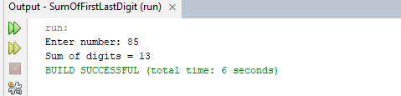

**14. Write a java program to Enter any number and print its reverse**.

package enteranynumber;

import java.util.Scanner;

public class EnterAnyNumber {

public static void main(String[] args) {

Scanner sc = new Scanner(System.in); System.out.print("Enter number: "); int n = sc.nextInt();

int rev =0;

while(n >0){

rev = rev*10 +(n%10);

n =n/10;

}

System.out.println("Reverse= " +rev);

}

}

**Output:**

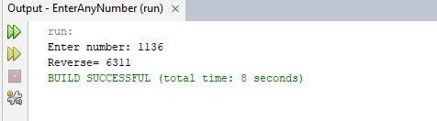

**15. Write a java program to Check whether a number is palindrome or not.**

package palindrome;

import java.util.Scanner;

public class Palindrome {

static void main(String[] args) {

Scanner sc = new Scanner(System.in); System.out.print("Enter number: "); int n = sc.nextInt();

int temp = 0;

int rev =0;

while(n >0){

rev = rev*10 +(n%10); n =n/10;

}

if(temp == rev)

System.out.println("Palindrome number " );

else

System.out.println(" Not Palindrome number " );

}

}

**Output:**

